Use-Case Realization Report (Design)
Add Exam

Issue <1.0>
Revision History
Date | Issue | Description | Author
<29/Aug/09> | <1.0> | <Initial version> | <Thomas Yap>

Table of Contents
1. Brief Description 4
2. Flow of Events 4
3. Flow of Events 4
3.1.1 Add Exam 4
4. Interaction Diagrams 5
4.1 Collaboration Diagram for Add Exam 5
4.2 Sequence Diagram for Add Exam 5
5. Participating Objects 5
6. Class Diagrams 6
6.1 Class Diagram for Add Exam 6
7. Derived Requirements 6

Use-Case Realization Report
Add Exam

Brief Description
This use case enables the controller to add new exam to exam pool. It involves displaying the menu and form for keying in the exam details.

Flow of Events
The standard flow of events for this use case and any exceptions are described in the following subsections. The events are described in terms of Actors and Design Objects.

Flow of Events
This use case covers the Exam Maintenance - Add Exam. The standard flow of these events is described below.

Add Exam
The running of the application is shown in section 3.1. The flow of event is as follow:

- When the application start, the first operation to be performed is the startup operation of the main controller. This operation will create all the control objects and the entity objects necessary for operation Add Exam:
  - The control object created is: MCQBL Controller
  - The entity object created is: mcq_exam_master.

- The main controller will start the main function menu:
  - To start Add Exam, operation page_load() is activated by MCQBL Controller to display an Exam form.
  - Portal Admin then input the data.
  - Operation validation will validate the format of the entries.
  - Then MCQBL Controller will check for duplication.
  - If no issue found, MCQBL Controller will send a confirmation request to form Exam Interface.
  - Upon confirmation, the data will then be written to file using operation InsertExam() to entity object mcq_exam_master Table.
  - The adding request can be cancelled and no data will be stored by clicking Cancel button.
  - A confirmation message will be displayed by form Exam interface.

- Step 2 will be repeated until all new entries are added to the system. Then controller will terminate the application by issuing operation close.

Interaction Diagrams

Collaboration Diagram for Add Exam
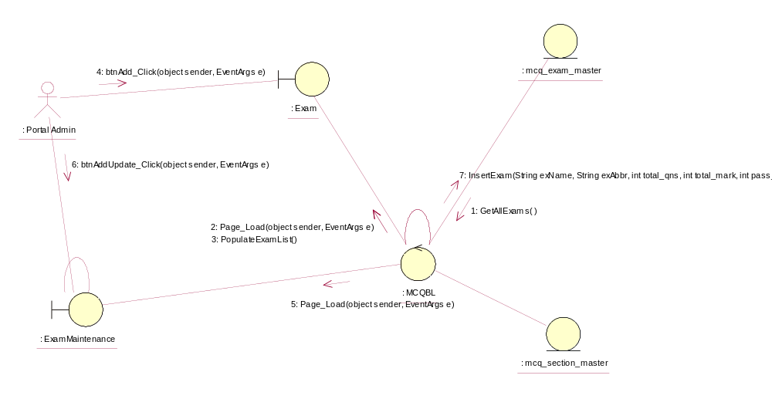

Sequence Diagram for Add Exam
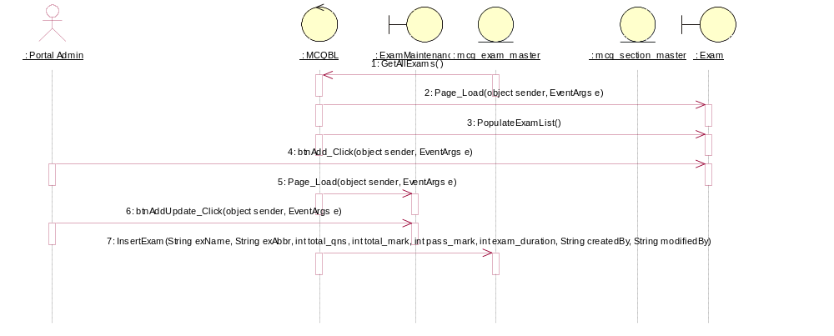

Participating Objects
: Exam

: ExamMaintenance

: mcq_exam_master

: mcq_section_master

: MCQBL

: Portal Admin

Class Diagrams

Class Diagram for Add Exam
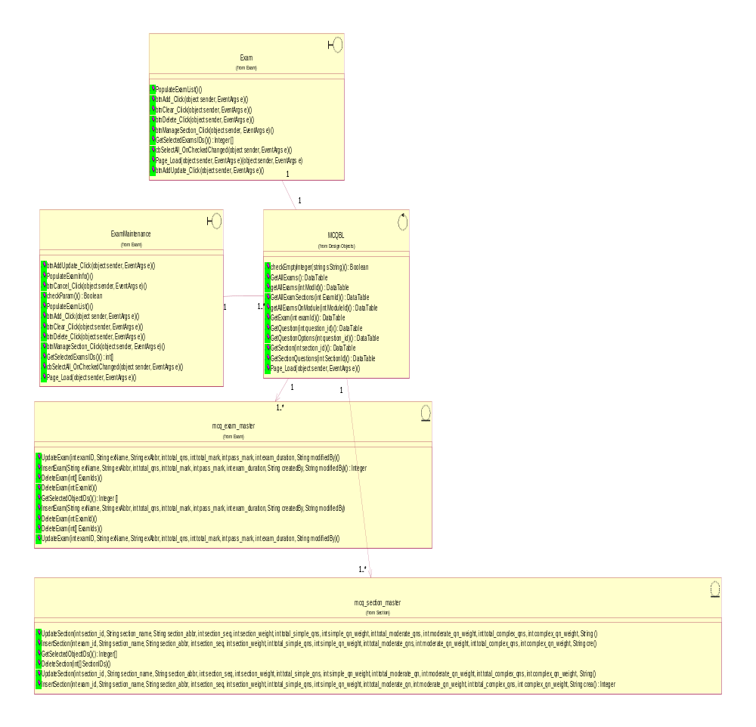

Derived Requirements
[enter the derived requirements here]

